INSTRUCTION MANUAL FOR SUSPENSION MIXER SM-3000
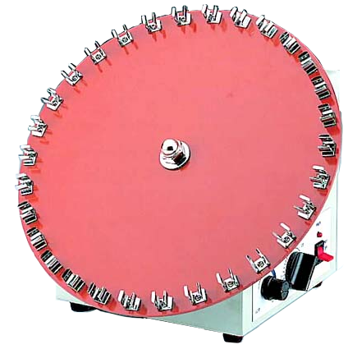
Clamp

Disc
Power indicator

Switch
(TIMER/OFF/CONT)

Timer
Speed controller
Warnings:
* Do not remove the mixer during operation.
* Place the mixer securely away from the edge of bench to avoid the mixer falling off the bench top.
* Do not disassemble the mixer by yourself. In the event of a malfunction, the mixer should be repaired by a qualified technician. Before repairing, turn off the power.

Steps:
- Place the mixer on a flat and stable bench top. Plug the mixer into a properly grounded outlet which corresponds with the electrical requirements on the label back on machine.
- Using the clamps on the disc to fix the test tubes.
- Select the switch model. You can place the ‘Switch’ at ‘TIMER’, ‘OFF’, or ‘CONT’ position. When the ‘Switch’ is at ‘TIMER’ or ‘CONT’ position, the ‘Power indicator’ lights.
3.1 If the Timer mode is selected, you can turn the ‘Timer’ to a required scale. There is a bell sound to be heard when the setting time is end.
* How to set the ‘Timer’ correctly?
Turn the ‘Timer’ over the required scale, then return the time calibration as a required scale. (For instance, you need 5 minutes for rotation, but you need to wind to 7 or 8 minute scale at first, then return back to 5 minute scale.)
3.2 If the ‘CONT’ mode is selected, the rotator will rotate continuously.
3.3 If the ‘OFF’ mode is selected, the power will be cut off.
- Turn the ‘Speed controller’ to a desired setting.

Maintenance and care:
Keep the machine clean all the time, so no routine maintenance is required. Cleaning can be done with a damp cloth. Avoid the use of solvents as they may damage the machine housing.

Circuit Diagram
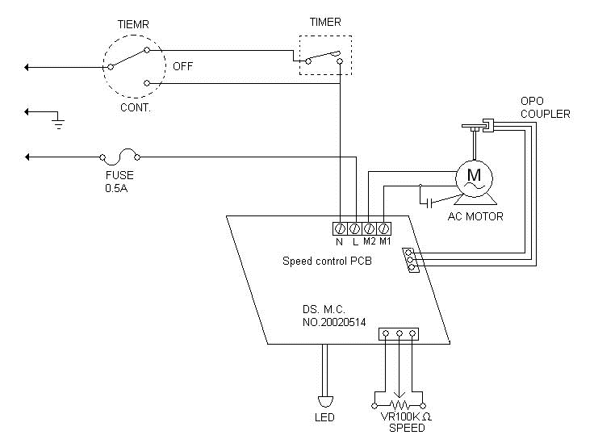

Troubleshooting Guide
Caution: Always disconnect the power cord before troubleshooting.
Trouble | Cause | Remedy
Instrument inoperative | Power cord not connected to outlet. | Plug in the power cord.
Instrument inoperative | Dead power output. | Change to different output.
Instrument inoperative | Fuse blown. | Change a new fuse.
Instrument inoperative | Defective electronic component. | Contact your distributor for repair.
Disc doesn’t rotate | Power is not on. | Place the switch at ‘Timer’ or ‘ON’ position.
Disc doesn’t rotate | Belt is not broken. | Contact your distributor for repair.
Disc doesn’t rotate | PC board is broken | Contact your distributor for repair.
Disc doesn’t rotate | Motor is broken. | Contact your distributor for repair.
Disc keep rotating when time is up | PC board is broken. | Contact your distributor for repair.
Speed is abnormal | PC board is broken. | Contact your distributor for repair.
Power indicator can not light up | The wiring of PC board and the power indicator is not well. | Contact your distributor for repair.
Power indicator can not light up | The power indicator is broken. | Contact your distributor for repair.
Timer is not accurate | Timer is not set by the correct procedures. | Read the operation manual and set it again.
Timer is not accurate | Timer is broken. | Contact your distributor for repair.

